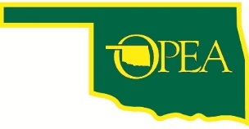

Registration
2017 OPEA Annual Convention & Delegate Assembly
August 25th & 26th

The Lodge at Lake Murray State Park, Admore, Oklahoma

Join your fellow OPEA members as we work for our future and have some fun along the way. Our annual convention is OPEA’s premier annual event and is an important step in our planning for action to improve state employment and retirement. If you have questions call OPEA at (405) 524-6764 or email opie@opea.org.

Name:______________________________________________________

Home Address: _______________________________________________

City:_____________________________ State:___ Zip Code:___________

Telephone:____________________ Email:_________________________

Arrival Date (circle one) August 25th/August 26th T-Shirt Size __________

□ I will attend the Friday night hayride and cookout for members plus 2 guests per member. Number Attending ______ (please RSVP to ensure an accurate count)

Breakfast and Lunch on Saturday will be for registered OPEA members only
To reserve your room, please call the Lodge at Lake Murray at (580) 223-4044

Please complete and mail to
Oklahoma Public Employees Association
13 NE 28th St., Oklahoma City, OK 73105

